COVID-19 Vaccine Schedule – OCT 2021 (v5)  The COVID-19 vaccine is available to ALL persons 12 years and over  First and second doses are currently available to all persons.  Boosters are being administered in phases (see below) |   PLEASE REMEMBER TO BRING YOUR OWN FACE MASK
Monday | Tuesday | Wednesday | Thursday | Friday | Saturday
18 | 19 | 20 | 21 | 22 | 23
1st & 2nd Dose available to all persons 12 years and older
Boosters (3rd Dose) available to healthcare workers, 50+ years old and clinically extremely vulnerable (see criteria below)*
NEWLANDS  COMMUNITY OFFICE  (#8 Homestead Crescent, behind Wendy’s)  4 - 7pm | LIONS CENTRE  11am – 3pm  4:30 – 7pm | LIONS CENTRE  11am – 3pm  4:30 – 7pm | LIONS CENTRE  9am – 12:30pm  PROSPECT COMMUNITY OFFICE  5pm -7pm | LIONS CENTRE  9am – 12:30pm  2 – 5pm | CAMANA BAY**  NEW LOCATION  9am – 12:30pm  2 – 5pm  (Canella Court, 2nd Floor, adjacent observation tower)
25 | 26 | 27 | 28 | 29 | 30
1st & 2nd Dose available to all persons 12 years and older
Boosters (3rd Dose) available to healthcare workers, 50+ years old & clinically extremely vulnerable (see criteria below)*
NO CLINIC | LIONS CENTRE  11am – 3pm  4:30 – 7pm | LIONS CENTRE  11am – 3pm  4:30 – 7pm  SISTER ISLANDS  Aston Rutty Centre  9am – 12pm | LIONS CENTRE  9am – 12:30pm  WEST BAY HEALTH CENTRE  5pm – 7pm | LIONS CENTRE  9am – 12:30pm  2 – 5pm | CAMANA BAY**  NEW LOCATION  9am – 12:30pm  2 – 5pm  (Canella Court, 2nd Floor, adjacent observation tower)
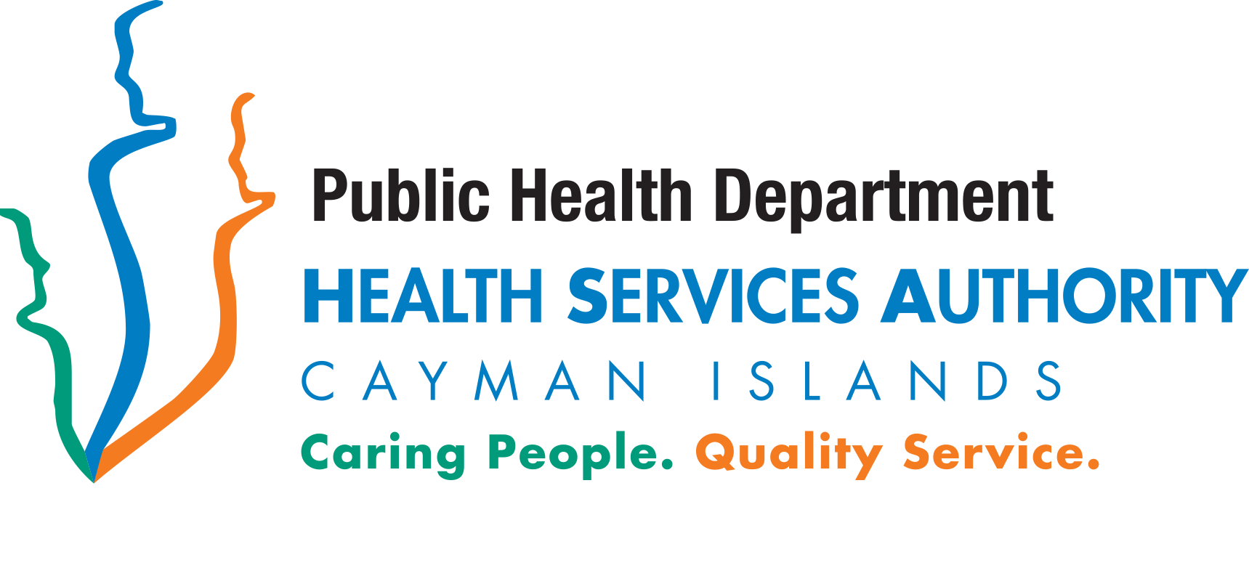

*Boosters are available to persons who meet the criteria below and have their 2nd dose MORE than 6 months ago

Clinically Extremely Vulnerable (high risk for COVID-19)

Solid organ transplant recipients

People with cancer who are undergoing active chemotherapy or radical radiotherapy

People with cancers of the blood or bone marrow such as leukaemia, lymphoma or myeloma who are at any stage of treatment

People having immunotherapy or other continuing antibody treatments for cancer

People having other targeted cancer treatments that can affect the immune system, such as protein kinase inhibitors or PARP inhibitors

People who have had bone marrow or stem cell transplants in the last 6 months or who are still taking immunosuppression drugs

People with severe respiratory conditions including all cystic fibrosis, severe asthma and severe chronic obstructive pulmonary disease (COPD)

People with rare diseases that significantly increase the risk of infections (such as severe combined immunodeficiency (SCID), homozygous sickle cell disease

People on immunosuppression therapies sufficient to significantly increase risk of infection

Problems with your spleen, for example splenectomy

People with down’s syndrome

People on dialysis or with chronic kidney disease (stage 5)

Women who are pregnant with significant heart disease, congenital or acquired

Other people who have also been classed as clinically extremely vulnerable, based on clinical judgement and an assessment of their needs – GPs and hospital clinicians determination

HEALTHCARE WORKERS

PERSONS AGED 50 YEARS AND OVER

GENERAL VACCINE INFO
- When receiving your 2nd or 3rd dose, you MUST also bring along your vaccination card reflecting your previous doses
- The date on your vaccination card for the 2nd dose is the earliest that is recommended
- Parental consent required for anyone 12 – 17 years old
- All persons must present photo identification showing date of birth
- Facemask required – Please bring your own.
- (Do NOT laminate your card)
Most up to date schedule available at www.hsa.ky

