For 2015 the total rainfall was 47.29 inches or 8.91 inches below the 30 year average rainfall total of 56.20 inches. No pattern noted in annual rainfall totals.

For 2015 the average temperature was 82.9 F or 0.90 degrees above the 30 year average temperature of 81.8 F. Annual temperatures have increased for the past 4 years by a total of 1.2 degrees F. A similar pattern is observed in Cayman Brac with 2015 having a slightly lower temperature.

Below are the rainfall and temperature graphs for 2015.

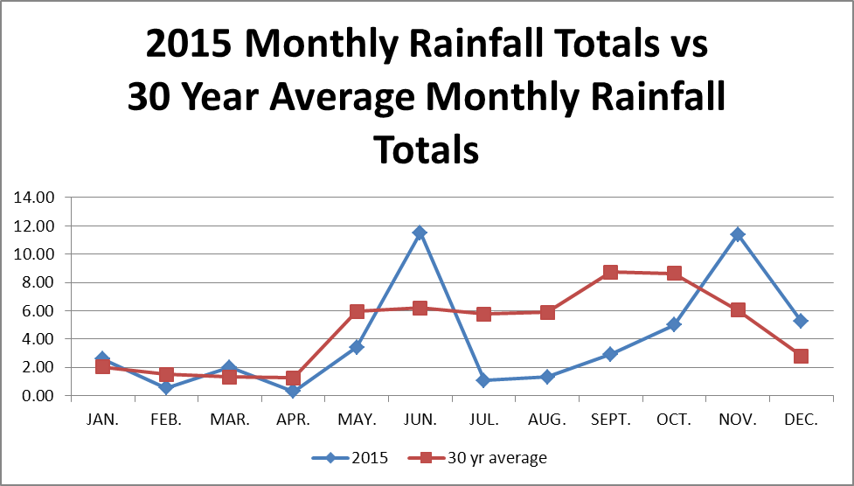

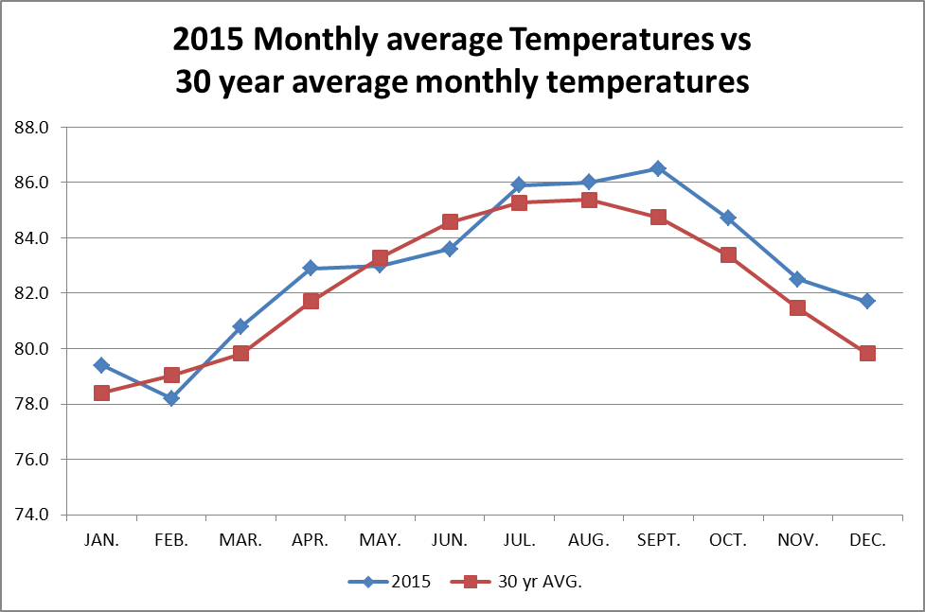

 |  |  |  |  | Grand Cayman data
 | Jan | Feb | Mar | Apr | May | Jun | Jul | Aug | Sep | Oct | Nov | Dec
30 Year Avg Rainfall mm | 51.84 | 38.12 | 33.50 | 32.21 | 151.40 | 157.50 | 146.79 | 149.77 | 221.96 | 219.78 | 153.72 | 70.96
2015 Mthly rainfall mm | 65.90 | 13.70 | 50.80 | 7.62 | 24.70 | 292.60 | 40.80 | 33.60 | 74.30 | 126.50 | 288.90 | 133.00
30 yr mthly AVG Temp C | 25.58 | 25.79 | 26.32 | 27.21 | 28.14 | 29.02 | 29.45 | 29.39 | 29.04 | 28.26 | 27.39 | 26.39
2015 mthly Temp C | 26.40 | 25.70 | 27.10 | 27.90 | 28.30 | 28.90 | 30.00 | 30.00 | 30.30 | 29.10 | 28.10 | 27.60

