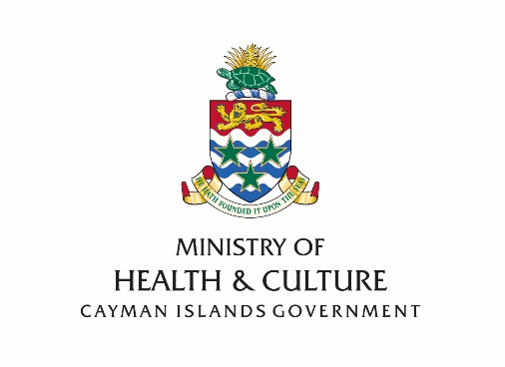
Landfill Site Environmental Review Task 2: Environmental Investigations Interpretative Report
Frequently Asked Questions: FAQ’s
What locations were used to collect information and what was collected at each site?
- The George Town landfill in Grand Cayman, which is the main landfill, was the primary site for the investigations. In addition, information was collected at the Cayman Brac Landfill and the Little Cayman Landfill.
- Investigation at the George Town landfill included the monitoring of existing and new groundwater wells, surface water and sediment sampling in canals/dykes surrounding the site and in North Sound, and dust, odour and landfill gas monitoring. Samples of vegetation surrounding the landfill and also from within North Sound were taken for analysis. Historical monitoring data for groundwater and surface water has also been considered within the interpretation of environmental effects.
- New groundwater boreholes were installed and sampled at the Cayman Brac landfill together with sampling of surface waters and monitoring and sampling of landfill gas. At the Little Cayman landfill, soil and surface water sampling was undertaken.

What Assessment Standards were used?
Several different assessment approaches were used to evaluate the environmental condition of the landfill sites:
- Soil, surface water and groundwater water data has generally been screened against assessment criteria based on the Florida Administrative Code (FAC) contaminant clean up target levels which are based on human health assessment;
- UK proposed standards under the Water Framework Directive (WFD) to protect the water environment have been used for nutrients and some metals within surface waters;
- Air quality data (including landfill and dust) have been assessed against UK Environment Agency (EA) and World Health Organisation (WHO) assessment criteria; and
- Amenity risk, such as windblown litter, for which there are no quantitative assessment standards, has been evaluated in accordance with UK EA H1 Annex ‘A’ guidance.

What were the Key Risks identified?
There were different risks uncovered at each landfill site:
- George Town landfill
  - Site users and visitors: arsenic in soils as well as hydrogen sulphide and methane;
  - Adjacent residents: nuisance from odour and landfill fires;
  - Adjacent commercial/industrial site users: hydrogen sulphide from sediments contaminated by various sources including the landfill, as well as nuisance from odour and landfill;
  - Groundwater: hydrocarbons from spills and overtopping of bunds;
  - Surface water: hydrocarbons from spills and overtopping of bunds, ammonia and orthophosphates from groundwater;
  - North Sound: ammonia and metals from canal water; and
  - The George Town landfill also has a significant detrimental visual impact from various viewpoints.

- Cayman Brac Landfill
  - Site users and visitors: methane from landfill gas;
  - Groundwater: hydrocarbons from waste oil storage spills to ground; and
  - Surface water: metals leaching from landfill.

- Little Cayman Landfill
  - Groundwater: hydrocarbons from waste oil disposal pit.

What are the chemicals that were found and how do they affect life in the Islands?
- Arsenic, hydrogen sulphide, methane, hydrocarbons, ammonia and orthophosphates were all chemicals found throughout all three landfills. They are chemicals that come from all the waste that is accumulated at the landfills.
- Arsenic was found at three sampling sites at the George Town Landfill at levels that exceed Florida soil clean-up assessment criteria but are generally below UK assessment criteria.
- None of these chemicals have long lasting effects on human, animal, and plant life unless there is continued exposure to high levels of them. Some - such as hydrogen sulphide and ammonia - will cause irritation of the eyes, nose, and/or skin of a person or animal that comes into direct contact with the substance but otherwise will not be of detriment to health.

Is there anything the public and the community can do?
- At the moment, the Cayman Islands Government continues with the development of a national solid waste management strategy, which will be fully developed and its implementation commenced by the 2016/2017 year. The NSWMS will address and seek to mitigate the key risks identified. Until the NSWMS is developed, we urge members of the public do their best to reduce the amount of waste being sent to the landfill by recycling and reusing items and home composting of their yard and food waste.
- We ask that you try to use our Waste Hierarchy model below in your daily lives for the betterment of the health of the environment of the Cayman Islands.
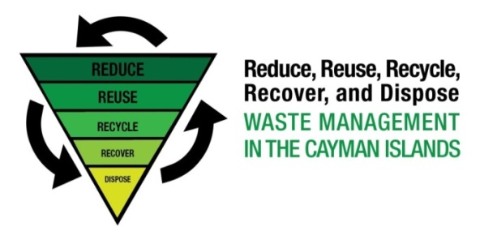

Where is CIG now with the Integrated Solid Waste Management System (ISWMS) and what comes next?
- We have completed Task 2 of Phase 1 out of three (3) Phases on a path to deliver a National Solid Waste Management Strategy (NSWMS) for the Cayman Islands. Phase 1 is the preparation of the NSWMS and the delivery of environmental investigations at the existing landfills on the islands.
- We are now in the process of preparing a Strategy based on the recommendations made in the Environmental Investigations Interpretative Report and the National Solid Waste Management Policy. It is anticipated that the Strategy will be completed by September 2015.
- Phase 2 is the preparation of an Outline Business Case, to deliver the NSWMS, which should be finalised by the end of December 2015 or early January 2016; and
- Phase 3 is the procurement of the new waste management services and infrastructure in line with the NSWMS.

Where can the public obtain further information?
The public can obtain further information by doing the following:-
- Visiting the Ministry of Health & Culture website at www.ministryofhealth.gov.ky or Facebook page.
- Emailing the Ministry of Health at h&hs@gov.ky or Telephoning (345) 244-2377.

