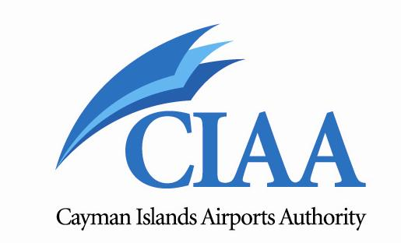

Board Paper
Authorization to Proceed with Sole-Source Procurement of Design-Build Contract Services

Prepared by: Board Building Committee
Presented by: Chairman of Board Building Committee

June 27, 2012

Table of Contents
1. Background 3
2. DEPARTURE LOUNGE 5
3. PASSENGER TRAFFIC AND AIRCRAFT MOVEMENTS 6
Figure 1: Passenger Traffic at ORIA 6
Figure 2: Aircraft Movements 7
Figure 3: Passenger Forecast 8
4. INFRASTRUCTURE NEED & SCOPE OF WORK 9
Figures 4: ORIA Terminal Building Ground Floor Plan 11
Figure 5: ORIA Departure Lounge Floor Plan Expansion 12
Figure 6: ORIA Terminal Building Rendering 13
5. AIRPORT FUNDING 14
6. PROJECT BENEFITS & RISKS 15
7. VALUE FOR MONEY 16
8. CONCLUSION AND RECOMMENDATION 18
8.1 Conclusion 18
8.3 Recommendation 19
Appendix 1: Letter from H.E. on CCC MOU and Tendering 20
Appendix 2: Board Chairman Letter to H.E. on CCC MOU and Tendering 22
Appendix 3: Board Chairman Letter to H.E. on CCC MOU and Tendering 24
Appendix 4: Board Chairman Letter to CCC on Airport Redevelopment 25
Appendix 5: Legal Advice from Ritch & Conolly on Sole Source Procurement 26

1. Background

1.1 Owen Roberts International Airport (ORIA) is a vital part of the Cayman Islands transportation system and is consequently of strategic importance, providing reliable scheduled international airline, domestic, charter, cargo operations, and general aviation services.

1.2 The current ORIA commercial airline terminal building was opened in 1985 and designed with space to handle a maximum of 500,000 passengers by the year 2000. Today ORIA handles approximately one million passengers per year or 100% increase over 1985.

1.3 Since the terminal building was first established it has undergone minor renovations and additions to accommodate a growing island population and an expanding economy. However, it has not kept pace with the level of service and convenience expected by the international business traveller or vacationer. The airport terminal reflects a combination of aging, cramped, and out-dated facilities and experience severely congested and uncomfortable environment, providing a poor level of service to travellers passing through the airport and to the employees who must work under cramped and inefficient conditions.

1.4 A list of how congestion negatively impacts airport customer experience are:

- Poor first and last impression to our customers;
- Unpleasant and stressful travel experience;
- Unsafe volume of people; presenting a potential safety hazard;
- Strain on facilities, processes and airport staff;
- Long passenger processing/waiting times;
- Lack of seating due to congestion in the departure hall (passengers have to sit on the floor);
- Insufficient restroom facilities;
- Lack of seating at restaurant (customers are seen waiting for a table for long periods of time or standing and eating);
- Added heat in halls due to volume of people
- Confusion as to which queue to join for boarding gate; and
- Crowds hinder sales for shops and restaurant.

1.5 While the CIAA has made great efforts to improve the facilities and systems (new AC systems, LED lighting, Air Curtains, ceilings, PA system, fire alarm system and ongoing restroom renovations) and have continued dialogue with the various CIAA units and airport partners to expedite passenger processing as best as possible, until a terminal expansion is undertaken, the terminal building will continue to experience overcrowding and congestion, especially in the departure lounge which was designed to handle 325 passengers but is handling more than 750 passengers during peak periods on weekends, from December to April.

1.6 With the present conditions, not only will the airport have a difficult time adding additional airlift from new carriers, but the resulting frustration could lead to visitors choosing a competitive destination. Ultimately, airlines could discontinue service and this would have a devastating impact on the Cayman Islands economy.

1.7 ORIA is a major economic driver and in order to continue to grow and develop at a sustainable rate and keep up with our competitors, as a matter of urgency, the ORIA terminal building must be expanded to comfortably and safely accommodate our current passenger numbers as well as have capacity for future growth.

2. DEPARTURE LOUNGE

2. 1 The departure lounge has a seating and circulation area of approximately 6500 ft². Using the International Air Transport Association (IATA) Service Standards for Wait/Circulate and assuming a level of service ‘C’, which is the level recommended by IATA and the normal design standard adopted by most airports, would require just over 20 ft² per passenger. The capacity of the lounge using this approach, excluding shops, toilets and café/bar would be 6500/20 = 325 passengers.

2. 2 Data collection observations which were made of terminal building operations over busy weekend periods (December 2011 - April 2012) show that maximum occupancy of the lounge was more than 750 passengers. With this number of passengers, each would have around 8.6 ft² of space each. This provides a level of service that is inadequate and uncomfortable.

2. 3 With the current schedule and without any flight delays, it is clear that at the weekends during the busy season, passengers are experiencing levels of service below the normal design standards in the departure lounge. This situation must be immediately corrected and appropriate levels of service provided without delay.

2. 4 The photos below illustrate the overcrowding experienced in ORIA departure lounge during peak periods and on weekends.

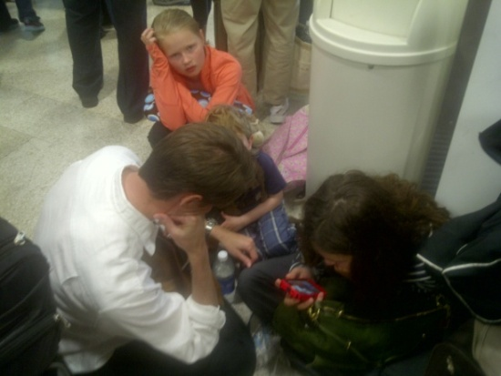 | 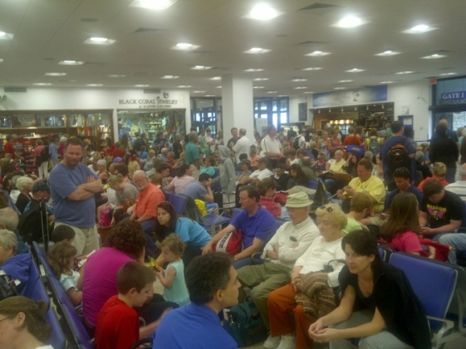

3. PASSENGER TRAFFIC AND AIRCRAFT MOVEMENTS

3.1 The chart in Figure 1 summarizes the historical total passenger traffic at ORIA from 2000 to 2011. The majority of passenger movements come from North America. Annual passenger totals peaked during 2000 with annual totals exceeding 970,000 passengers. Annual passenger totals declined between 2000 and 2005. This decline was a result of world events and natural disasters that had an adverse affect on the tourism industry in the Cayman Islands. The World Trade Center attacks occurred in September of 2001 and brought about a sharp decline in tourist travel throughout North America and the Caribbean. Annual passenger counts stabilized in 2002 and 2003 with totals exceeding 840,000. In 2004, Hurricane Ivan made its way through the western Caribbean. Ivan was the strongest storm of the 2004 Atlantic hurricane season causing severe damage to island infrastructure and hotel capacity, impacting tourism visits in the subsequent year.
3.2 Since 2005, passenger traffic has recovered strongly, increasing by 21% in 2006, by 14% in 2008 and is projected to grow by 4% in 2012. During the three year period from January 2009 to December 2011, passenger numbers grew steadily by 12% from 937,114 to 1,067,981 per annum, with an average growth rate of 4%.

Figure 1: Passenger Traffic at ORIA

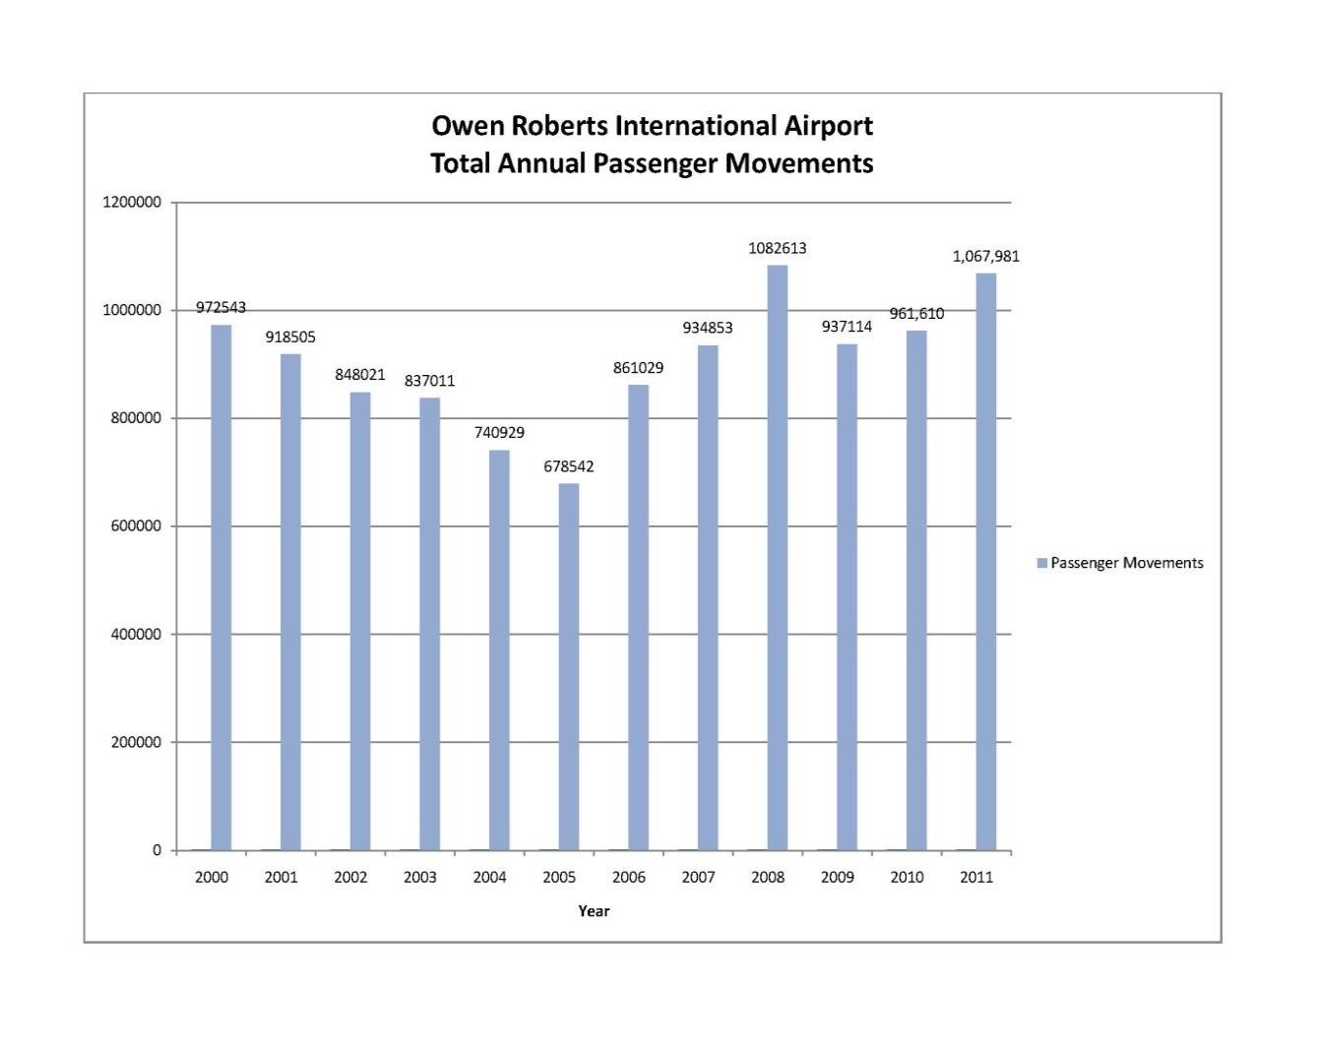

3.3 The existing terminal building has seating for 500 persons. Between 11:30 AM and 1:00 PM, more than 750 departing passengers require access to the departure lounge. The growth in passenger numbers over the years has meant that the existing terminal building and departure lounge is grossly inadequate. The provision of a new expanded terminal and associated infrastructure is consequently quite urgent. This urgency has recently been exacerbated by congestion in the departure lounge, primarily on weekends, between December and April.

3.4 Figure 2 shows historical aircraft movements (landings and takeoffs) at ORIA from 1987 to 2011. In 2011, ORIA handled approximately 24,160 aircraft movements, an increase of 1.2% from 2010. Aircraft movements peaked at 25,847 in 2007 then declined by 2% in 2008. This decline was due largely to declining General Aviation aircraft movements.

3.5 During the three year period from January 2009 to December 2011, aircraft movements increased from 23,414 to 24,160 per annum.

Figure 2: Aircraft Movements

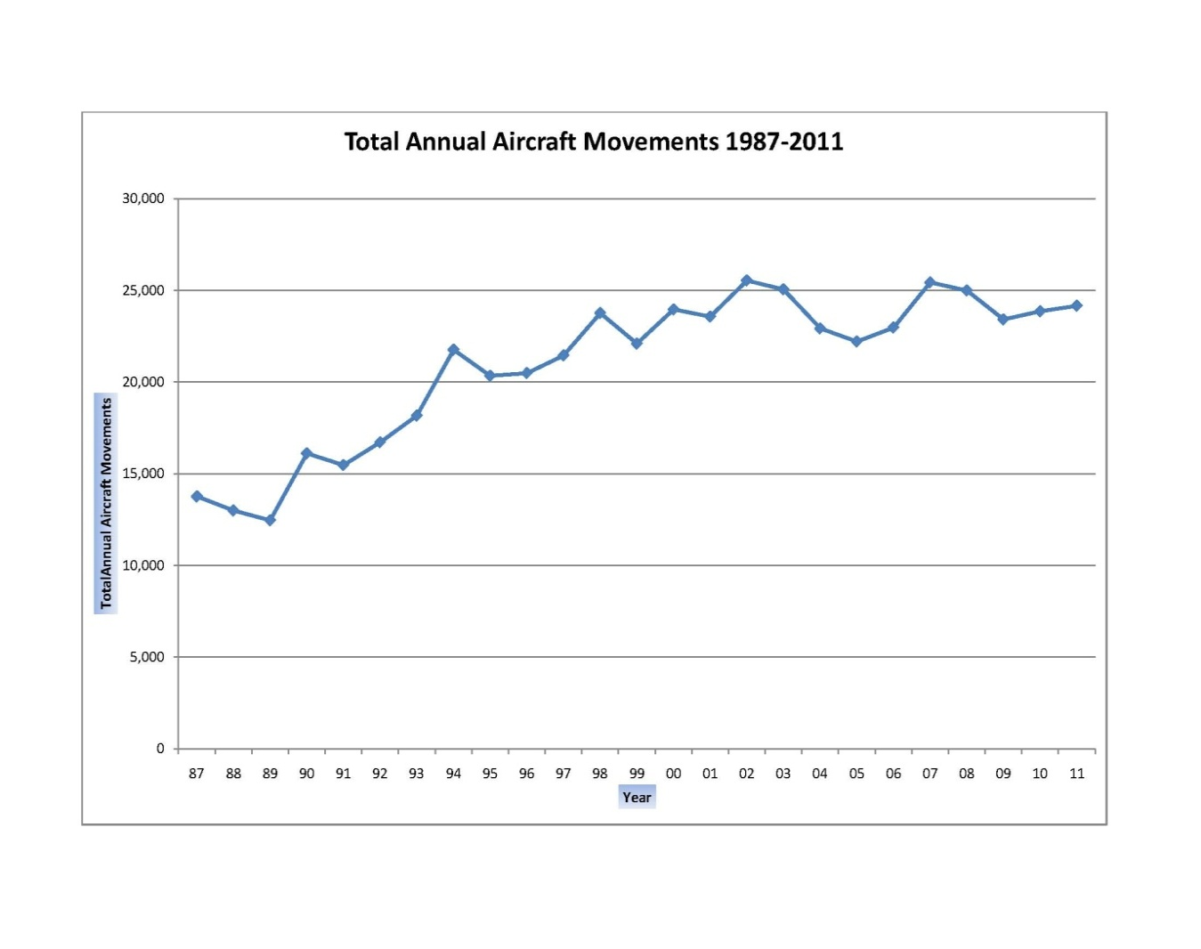

3.6 The forecast of total annual passengers from 2008 to 2028 at 5-year increments are presented in Figures 3. In the most likely forecast, traffic is forecast to reach over 1.5 million by 2018 and approximately 2.1 million by 2028. The average growth rate over the next 20 years in the most likely forecast is 3.5% per annum. Actual passenger traffic recorded in 2011 represents the 2011 forecasted numbers.

Figure 3: Passenger Forecast

4. INFRASTRUCTURE NEED & SCOPE OF WORK

4.1 The history of ORIA development has included several feasibility studies into different design concepts for the terminal building. Various studies investigated the advantages and disadvantages of refurbishing the existing terminal or constructing a new purpose built facility over the existing terminal. The studies sought to cater for increasing numbers of passengers and provide the facilities and services that are currently needed in the existing terminal, and included the following objectives:

- Doubling of current capacity from 1M to 2M annual passengers with a 20 year activity forecast;
- Enhanced customer experience;
- Introduction of boarding bridges;
- Improve concessions and customer satisfaction; and
- Compliance with regulatory requirements.

4.2 The expansion of the existing departure lounge is necessary because of safety concerns resulting from observation of overcrowding, especially during peak period operations. The design and construction of this necessary space is imminent and intended to:

- Provide sufficient customer space and prevent traffic congestion;
- Provide future space for handling forecasted capacity demand; and
- Have minimal impact on day-to-day airport operations during construction phase.

4.3 The scope of works for a runway extension to meet RESA requirements and to extend 1,500 ft into the North Sound cannot be funded by current CIAA funds. For this reason possible financing will have to be further investigated and the subsequent section of this business case will focus on addressing the known departure lounge congestion problem.

4.4 The redevelopment of the departure lounge will involve a design-build concept that includes expanding the current ground floor to 16,000 ft² and constructing a new 29,000 ft² upper floor departure lounge. Detailed plans will be developed using the building footprint of previously designed terminal building plans. A ground floor drawing along with proposed ground floor departure lounge expansion and artist rendering of future terminal building and completed upper floor with boarding bridges is depicted in Figures 4, 5 and 6. Works to immediately address the departure lounge congestion will include the following and financed with current CIAA accumulated passenger facility fees.

- Detailed design drawings and costing;
- New concession spaces;
- New restrooms;
- New VIP lounge;
- Upgrade MEP equipment and the installation of a new sprinkler system;
- Install new escalator and elevator up to departure lounge; and
- Sterile corridor to new aircraft positions for future boarding bridges.

Figures 4: ORIA Terminal Building Ground Floor Plan

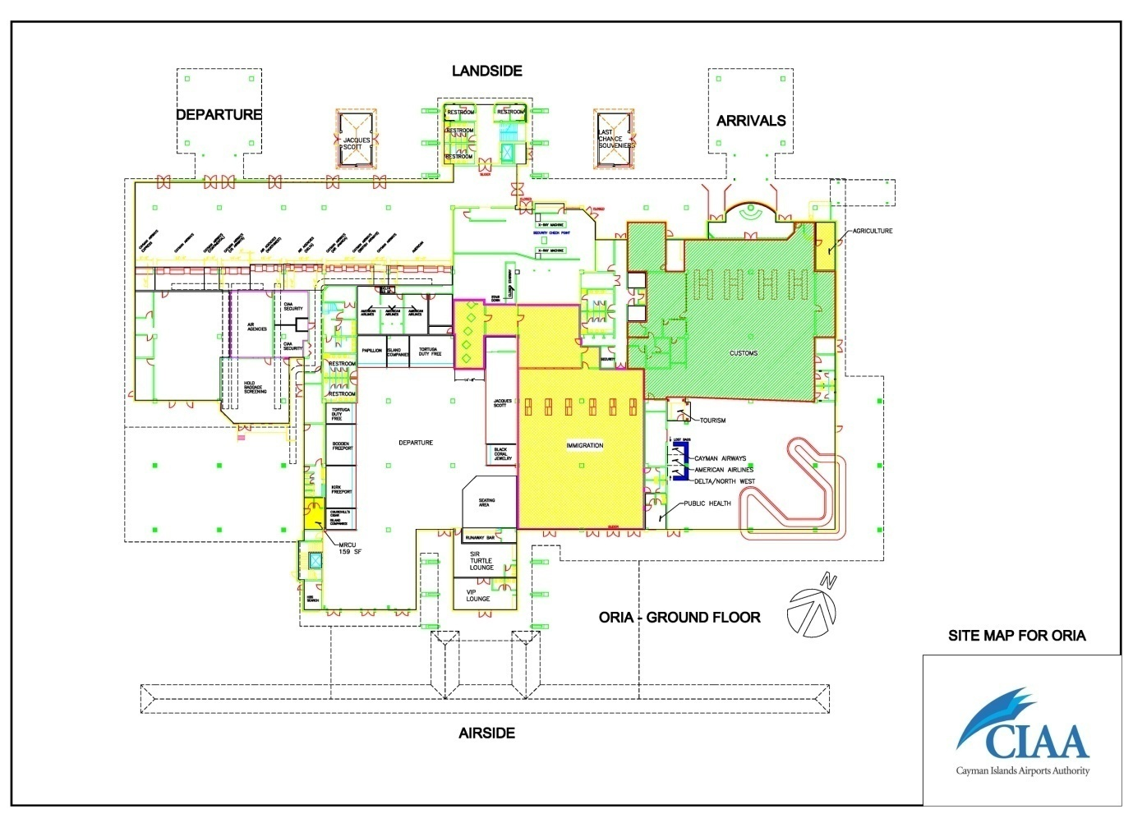

Figure 5: ORIA Departure Lounge Floor Plan Expansion

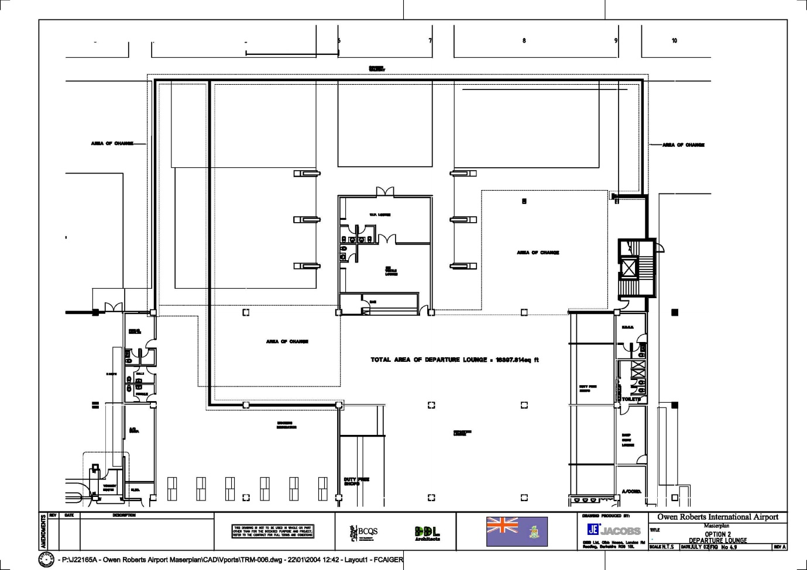

Figure 6: ORIA Terminal Building Rendering

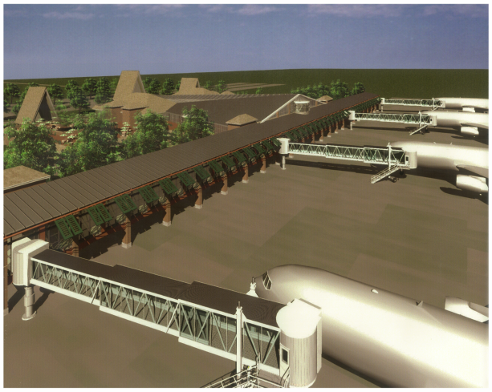 | 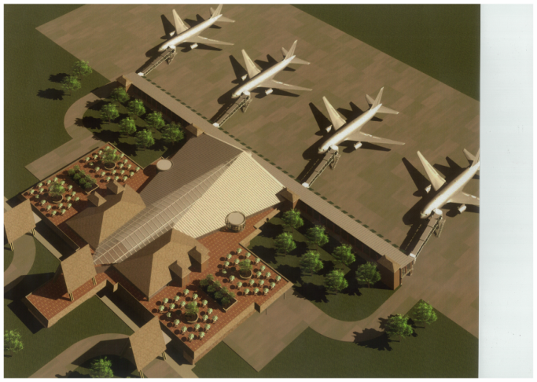

5. AIRPORT FUNDING

5.1 The CIAA operates ORIA with self funding activities meeting the operational costs and providing reserve funds for future infrastructure improvements. Revenue is generated from a passenger facility charge, departure and security taxes, aircraft landing and parking fees, concession rental, advertising etc.

5.2 The CIAA budgets to make an operating profit each year and funds generated from the passenger facility charge (PFC) is placed into an airport improvement fund that can only be used for airport improvement capital projects and redevelopment. Airport capital projects are funded from the PFC, meaning that loans are not required for smaller development projects. Major capital redevelopment works such as the pending construction of a new terminal and associated infrastructure are beyond the capacity of accumulated cash surpluses. However, the proposed departure lounge infrastructure expansion project will be funded without borrowings using reserve PFC funds.

5.3 Cost Estimates of Departure Lounge Expansion
Departure Hall | Costs
Expand departure lounge (16,000 ft²) | $4,000,000.00
New upper floor departure hall, VIP lounge and concessions (29,000 ft²) | $7,250,000.00
Escalators, elevator and corridor | $925,000.00
Consulting, design and management fees | $1,200,000.00
Estimated Budget | $13,375,000.00

5.4 The objective of investment in the ORIA terminal building is to ensure the continued provision of safe, efficient and convenient air transport to Cayman Islands visitors and residents. ORIA is operated as a highly successful and profitable business that generates a cash reserve and the terminal building development presented is a viable project.

5.5 Though the estimated project cost of $13,375,000.00 is substantial, it can be financed by the CIAA without borrowing by using reserve cash that has been collected from a passenger facility charge that was introduced in January 2009. In spite of the capital development cost involved, ORIA operations will remain sustainable, as funds collected from the passenger facility charge cannot be used for day-to-day operations and was introduced only for the purpose of financing the redevelopment of ORIA.

5.6 The total amount collected from CIAA passenger facility charge at 30th April 2012 is:

$14,422,380.48

6. PROJECT BENEFITS & RISKS

6.1 A February 2011 Airport Visitor Experience Assessment carried out by Deloitte and the Cayman Islands Department of Tourism confirmed that the current airport infrastructure was identified as having a negative impact to the visitor’s experience. Deloitte's assessment report recommended updating the current departure lounge area to provide immediate positive impacts to the visitor’s experience as this is their last point of contact with the island.

6.2 The vital role of ORIA is strongly linked to the Cayman Islands Tourism product and it is imperative that necessary action be taken to make not only the visitor's airport experience pleasant, but residents as well.

6.3 Airports are specifically identified as critical infrastructure for economic, business, tourism and investment development purposes such as the proposed Narayana Medical Centre hospital project. The development of ORIA departure lounge is arguably a critical project that will help improve the current airport experience and provide our customers with professional, innovative airport services and facilities in a safe, efficient manner.

6.4 The main risks resulting from not addressing the current overcrowding situation include, but are not limited to:

- Reduced ability to cater for larger passenger volumes;
- Increased travel time for passengers due to delays resulting from restricting number of passengers in the departure hall;
- Reduced opportunities for concessions and other business within the airport;
- Reduced opportunities for businesses outside the airport area as a result of reduced passenger numbers;
- Reduced monetary benefits for the airport as a result of above points;
- Reduced employment opportunities; and
- Reduced productivity for airlines.

6.5 The estimated cost in dollar figures caused by the above risks has not been quantified and a Cost Benefit Analysis would have to be undertaken to show the negative net economic benefits.

7. VALUE FOR MONEY

7.1 The expanded departure lounge will provide much needed space to ORIA terminal building now and in the foreseeable future and will reduce the current state of congestion being experienced in the terminal. The risk of over capacity, which presents safety issues during evacuation events, is a significant liability that must be mitigated. At an estimated cost of CI$13,325,000.00 the immediate priority includes expanding the departure lounge ground floor and developing a new upper floor departure lounge, VIP lounge, concessions, escalators, elevator, and covered walk way to facilitate future boarding bridges.

7.2 It is important that a design-build sole-source integrated procurement route, which will achieve value for money is vigorously pursued to immediately mitigate the congestion problem. The use of a single contractor for the management and delivery of design and construction in the most efficient way, within budget, including demonstrating during the design and construction period that performance parameters can be met in accordance with a pre-agreed contract is the CIAA's preferred option at this time.

7.3 In selecting a design-build team evaluations are to be carried out to ensure minimum experience and qualifications are satisfied. It is critical that a contractor has the required experience, similar to that of the project being considered, and the ability to bear the liability that is inherent to that project.

7.4 Arch and Godfrey, the original contractors that built the terminal in the 80’s, has displayed the knowledge, experience and expertise to carry-out projects of this magnitude. In fact, their track record with ORIA includes contract completion well in advance of intended completion dates, and a $500,000 savings. They have been involved in airport renovation and expansion works since the terminal was opened in 1985. In the aftermath of Hurricane Ivan, Arch and Godfrey (A&G) was hired in September 2004 as a sole-source contractor for repairs to the terminal building. Management at the time took this decision because:

- A&G was the original contractor for the terminal project in the early 80's;
- A&G was the primary contractor for nearly all expansion projects at the terminal since it was built; and
- A&G had the best buying power for materials, equipment and labor in a post-hurricane market where material was difficult to acquire.

7.5 The rigorous identification, allocation, and management of risk throughout a project are some of the key factors driving value for money assessments. There are various benefits in proper allocation of risk. These benefits flow from ensuring that the many different types of risks inherent in a major investment program, for example construction risk or the risk associated with the design of the building and its appropriateness for providing the required service, are borne by the party who is best positioned to manage them. This allocation reduces risk that the CIAA would otherwise have to bear, ultimately providing savings. Selecting a construction firm, such as Arch and Godfrey, capable of managing these risks, is paramount to a projects success.
7.6 Arch and Godfrey's past performance at ORIA confirms that as a sole source service provider they are capable of achieving the necessary project objectives through minimization of costs, and delivery of effective project management, including design and construction. This sole-source justification is based on the following factors:

- Arch & Godfrey has expertise that is capable of providing full design-build services;
- In 1984, Arch & Godfrey built the terminal building with contract completion 4 months ahead of schedule, with recognized $500,000 cost savings;
- In 1996, Arch & Godfrey completed expansion work on the check-in hall, baggage holding and customs areas, despite the complication of additional work introduced during the course of the contract;
- Post Hurricane Ivan, Arch & Godfrey carried out immediate, intensive and successful response to restore building and operations back to normal;
- Previous work carried out was technically satisfactory, completed on time within budget;
- In 2004, Arch & Godfrey was selected by the Government to design-build a proposed terminal building expansion;
- In 2005 and 2008, Arch & Godfrey pre-qualified to tender for a proposed terminal building expansion project;
- Arch & Godfrey still employs many of the key staff and consultants who participated in previous terminal building work;
- Willing and able to commit key managerial and technical staff to new expansion work; and
- No significant benefit will result through solicitation of services from another design-build service provider.

8. CONCLUSION AND RECOMMENDATIONS

8.1 Conclusion
8.1.1 The lack of adequate departure lounge space place considerable constraints on Owen Roberts International Airport. Considering the economic importance of the facility and its contribution to the Cayman Islands economy, the CIAA cannot afford to do nothing to address this known capacity demand problem. The types of benefits that will have a net positive impact when addressed include:

- Positive safety impacts as a result of increased space;
- Improved visitor experience;
- More efficient travel time;
- Additional value for concession and other operations within the airport and a significant increase in value for local businesses outside the airport area, due to spending by additional visitors; and
- Additional monetary benefits for the airport from increases in revenues from existing and new passengers.

8.1.2 Proposals by the below listed companies who in the past had expressed interest either in the financing or redevelopment of Owen Roberts International Airport were considered by the Board between November 2009 and May 2012. With the exception of Island Air and Arch & Godfrey, the majority of companies were all based overseas. Island Air's expression of interest was in the redevelopment of the current general aviation terminal. Whereas Arch & Godfrey's May 16, 2012 proposal included a solution for addressing the terminal building departure lounge congestion problem.

- Island Air;
- Raytheon;
- Aviation Facilities Company Inc;
- Universal;
- Malphrus;
- Turner Construction;
- Cushman & Wakefield;
- Ashtrom B.V.;
- Canadian Commercial Corporation; and
- Arch & Godfrey

8.1.3 When analyzed qualitatively, Arch and Godfrey provides adequate value for money and has expressed their willingness to undertake the proposed terminal departure lounge expansion. They have provided the flexibility and qualifications paramount to the success of this sensitive project scope. Management is of the opinion that if Arch and Godfrey’s service is utilized on this project the probability of a timely and cost effective completion will be extremely high.

8.1.4 A review of past bill of quantities produced by BCQS and independent evaluation carried out by the CIAA Project Manager confirm that the current market price in the Cayman Islands for redevelopment of the departure lounge is in the range of CI $250.00/ft². This is very similar to the rates proposed by Arch and Godfrey in their terminal improvement proposal that was presented to the CIAA Board of Directors on Wednesday, May 16, 2012.

8.1.5 Regulation 37 (2) of the Cayman Islands Financial Regulations (2010 Revision) as set out below maybe invoked if the Airports Authority is satisfied that only Arch & Godfrey can supply the relevant design-build services to address redevelopment of the terminal building departure lounge.

"In the case of a contract for the purchase of supplies, services and assets over twenty thousand dollars, where, in the opinion of the chief officer of a prescribed entity, statutory authority or government company, only one supplier can provide the supplies, services or assets, the chief officer is not required to offer for public tender such contract but -
- he shall comply with regulation 41; and
- he shall be subject to an overriding requirement to ensure value for money.

8.1.6 Regulation 41 provided that:

"Tenders submitted for any contract with a value of less than two hundred and fifty thousand dollars shall be evaluated by a tenders committee established by the chief officer of the purchasing prescribed entity, statutory authority or government company."

8.2 As part of its deliberations on sole source procurement, the Board should review and consider the tendering and sole source procurement information in the correspondence found in the attached Appendices.

8.3 Recommendations
8.3.1 Congestion in the Owen Roberts International Airport terminal building departure lounge must be urgently mitigated. The Airports Authority should consider The Airports Authority Board is accordingly requested to invoke Regulation 37 (2) of the Cayman Islands Financial Regulations (2010 Revision) and authorize its Board Building Committee to negotiate a sole- source service contract with Arch & Godfrey to design-build urgently needed departure lounge space at Owen Roberts International Airport. A negotiated contract package will be presented to the Board for Board review and approval before any design-build contract is awarded to Arch & Godfrey.

Appendix 1: Letter from H.E. on CCC MOU and Tendering

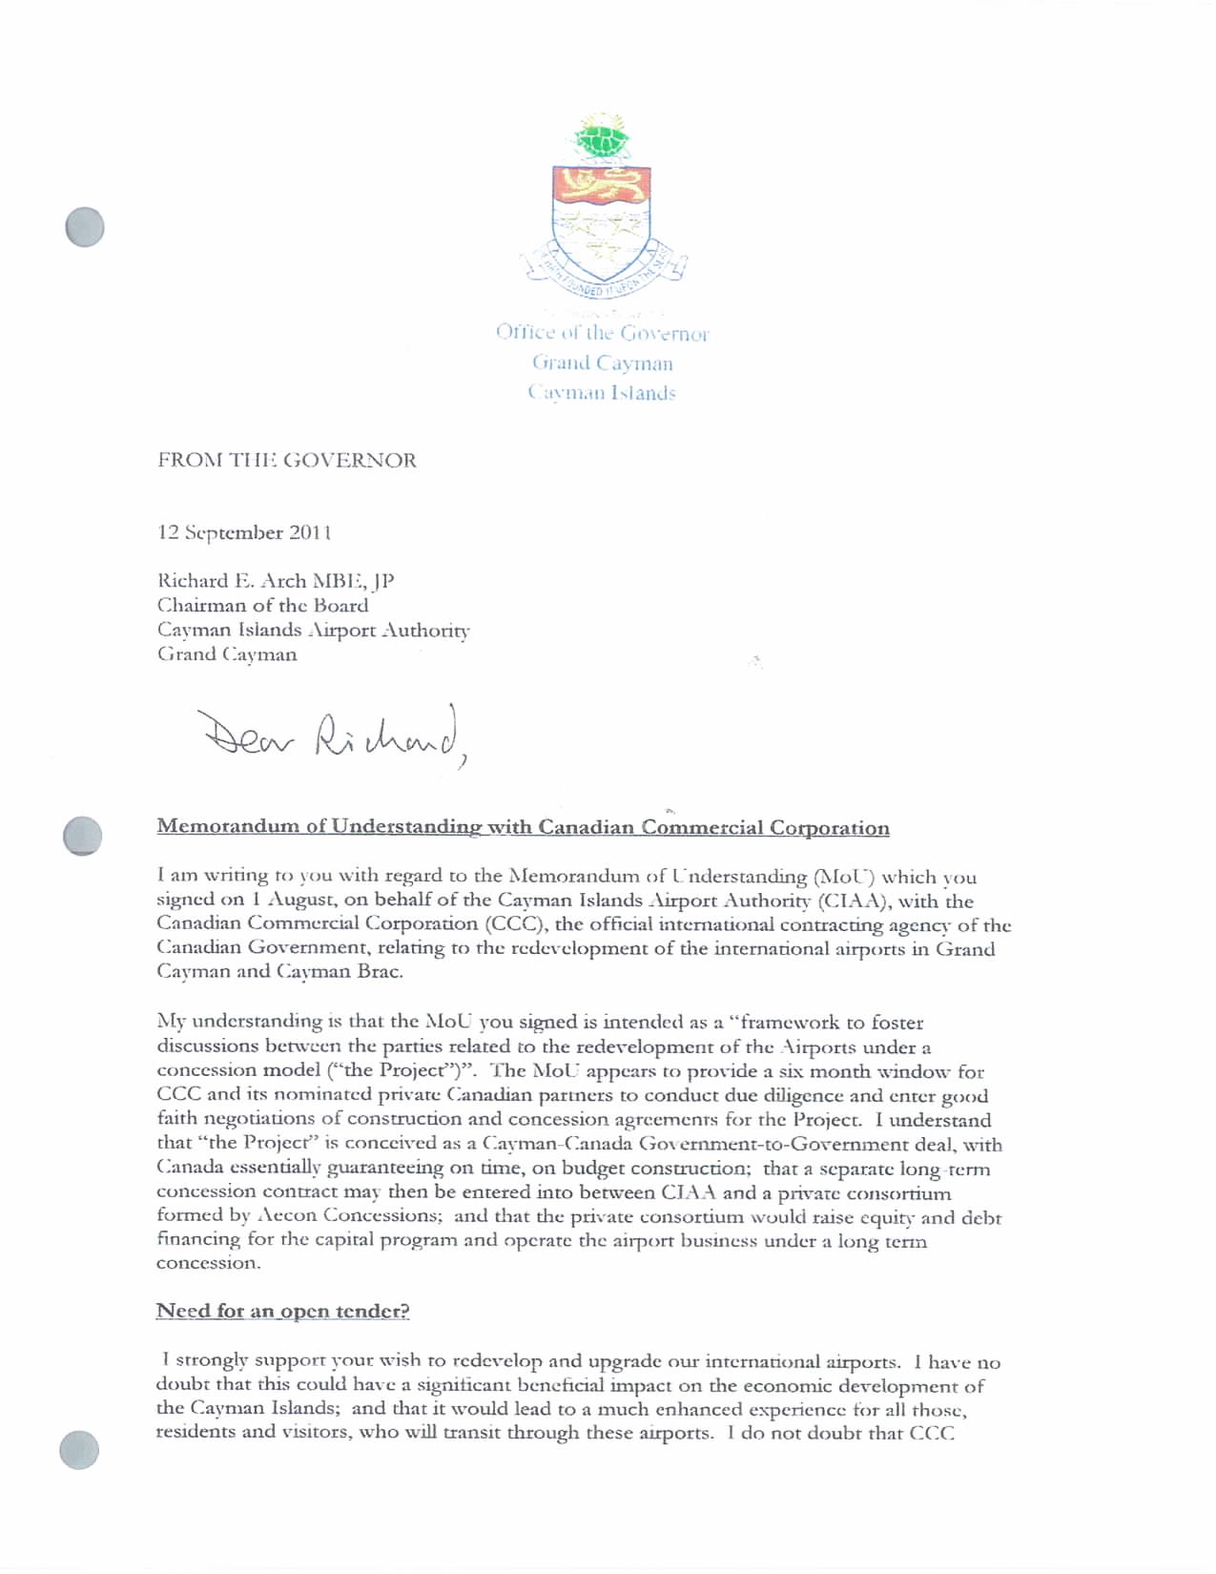

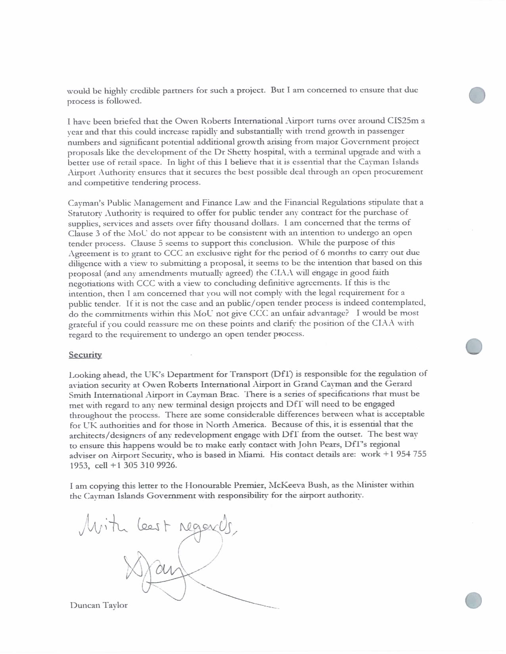

Appendix 2: Board Chairman Letter to H.E. on CCC MOU and Tendering

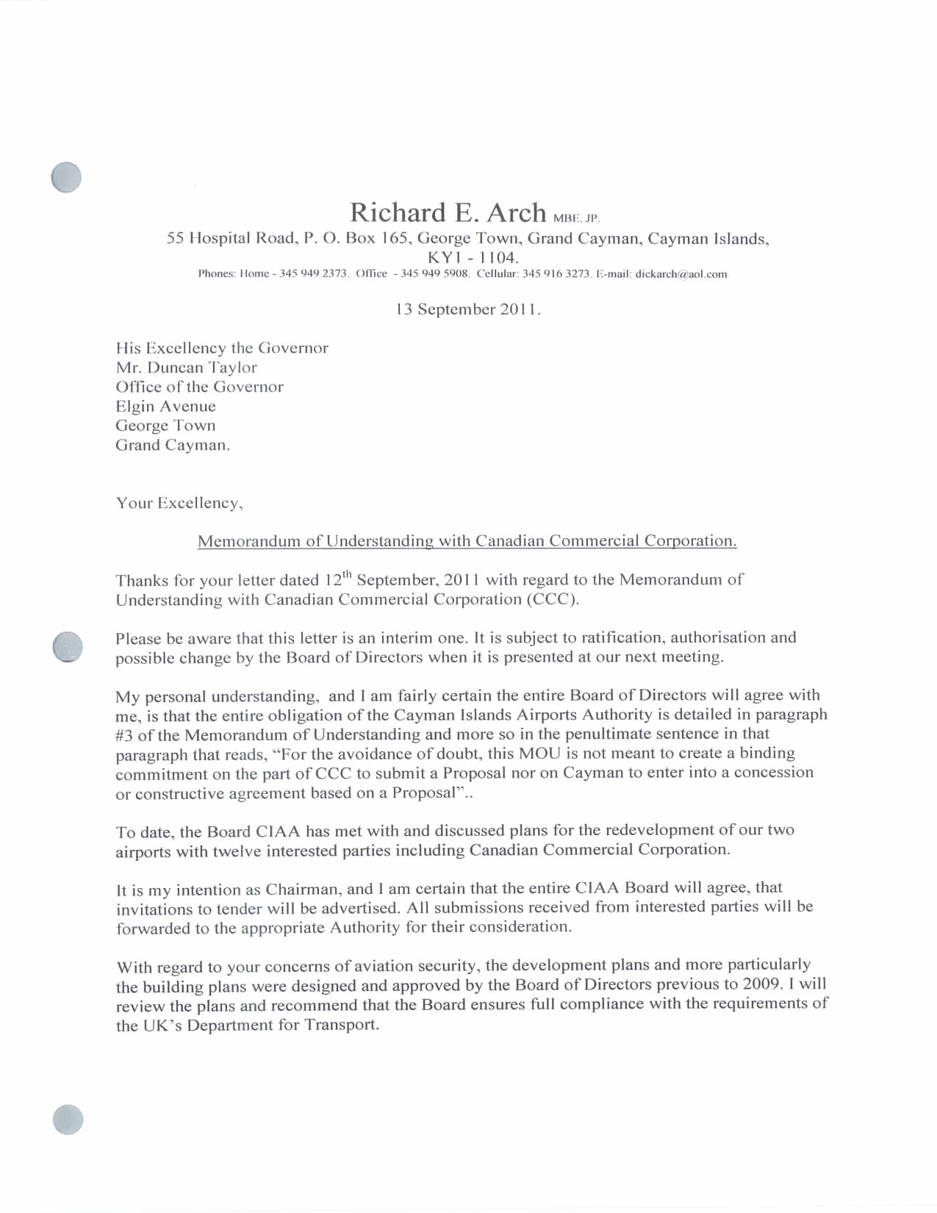

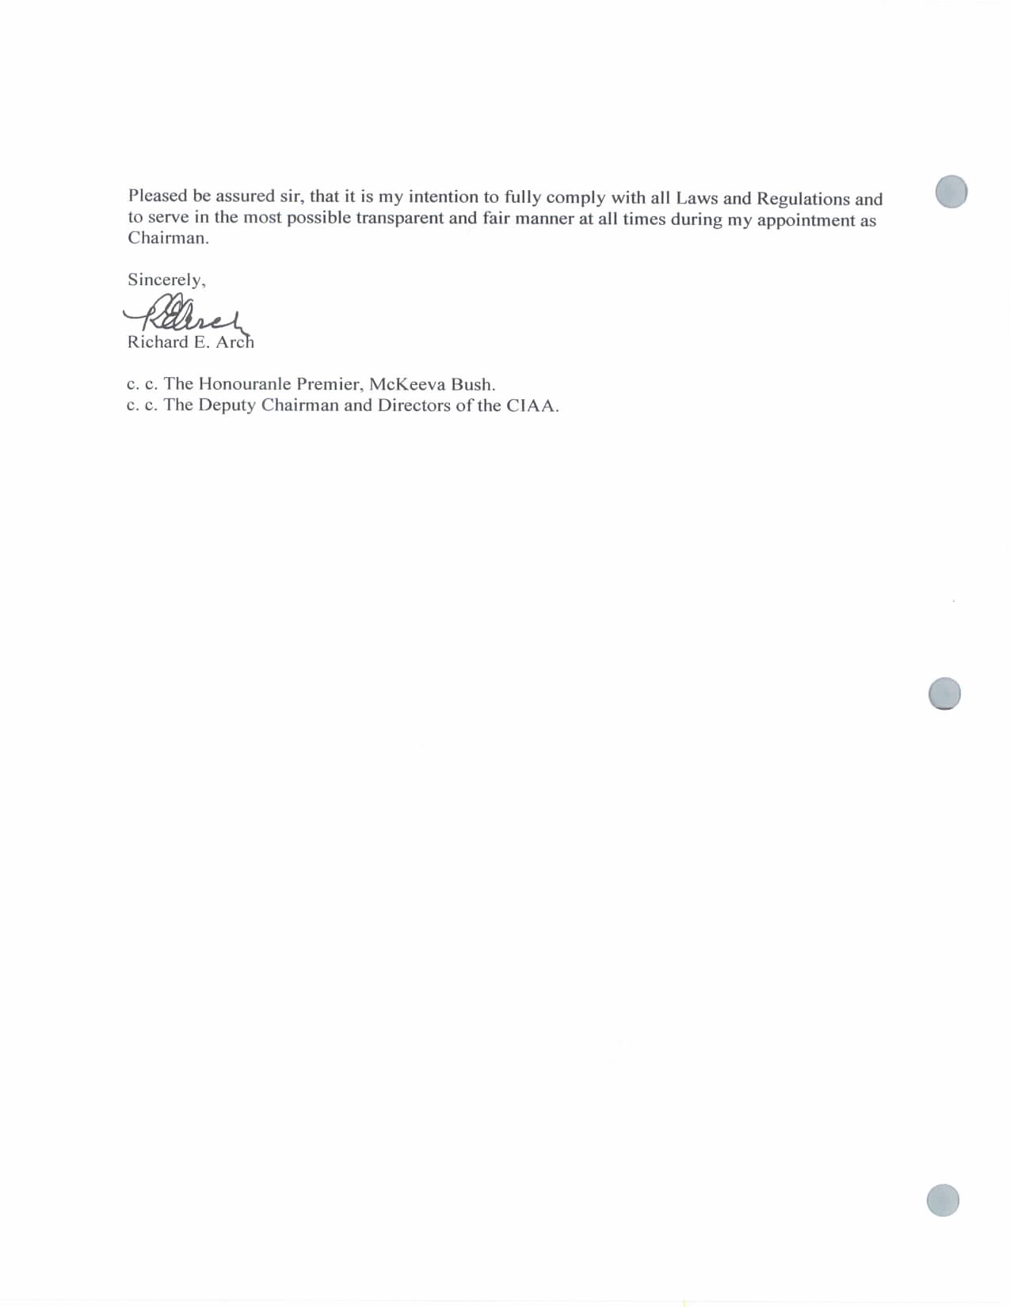

Appendix 3: Board Chairman Letter to H.E. on CCC MOU and Tendering

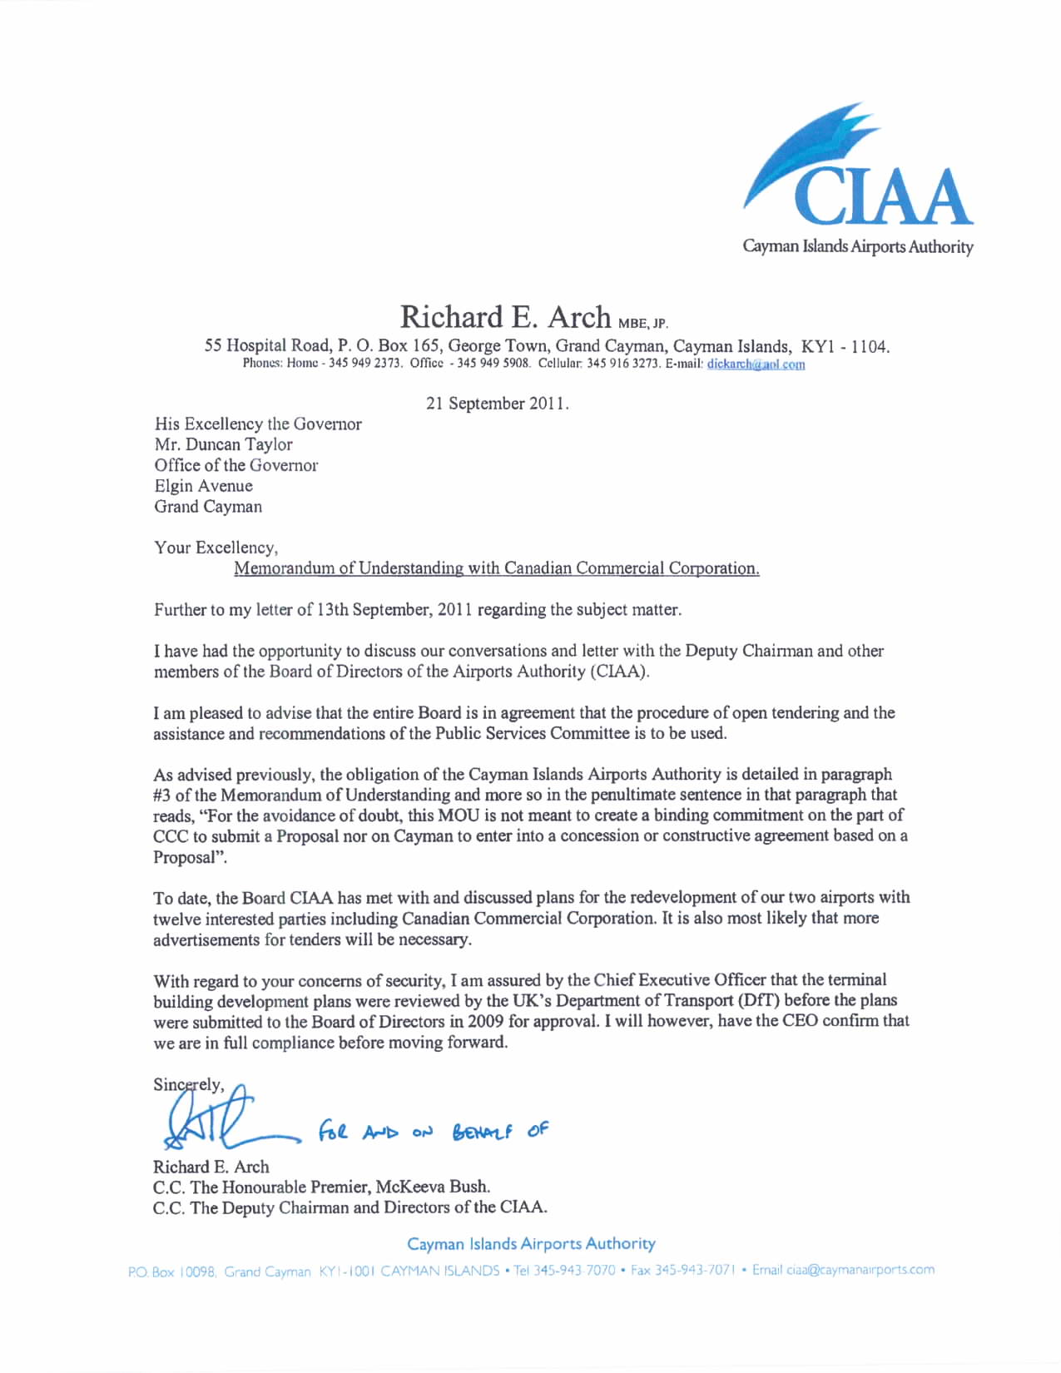

Appendix 4: Board Chairman Letter to CCC on Airport Redevelopment

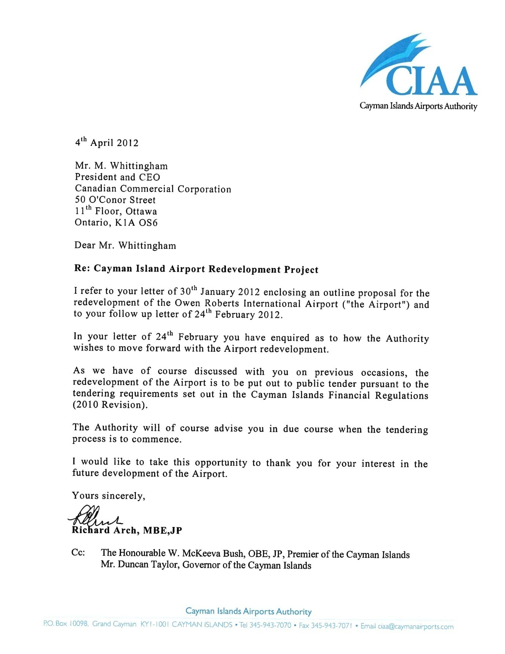

Appendix 5: Legal Advice from Ritch & Conolly on Sole Source Procurement

[insert R&C advice on sole source procurement]

